Azure Virtual machine

1. Login to portol.azure.com and sign in with a subscription in azure.

2. open virtual machine from the list of resources in the azure.

3. click on add to dd a new virtual machine.

4. configuring a virtual machine is as follows:

(a): configuring storage type and server images in a virtual machine

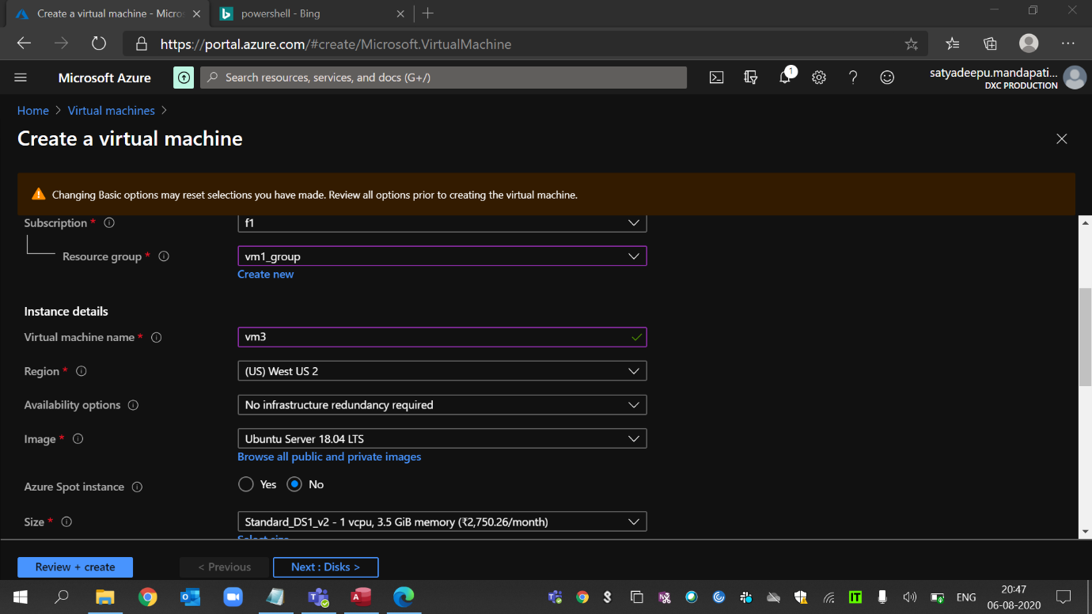

(b): Adding virtual Disks to the machine

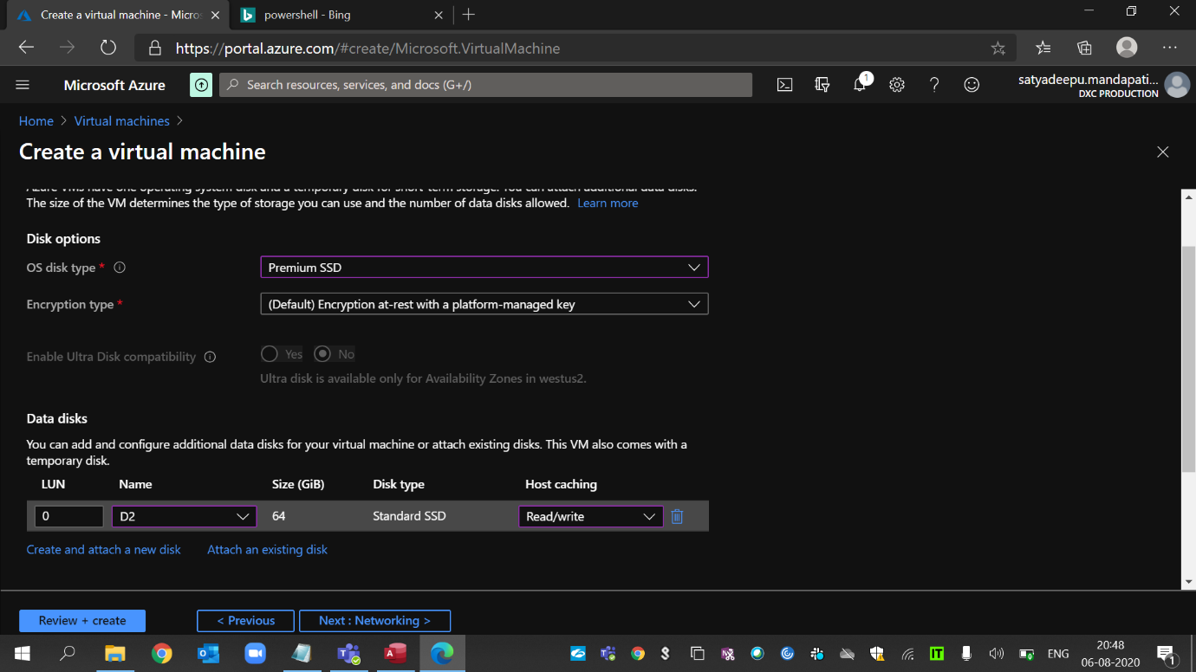

(c). Setting pa VM to auto-shutdown at 5.30 pm

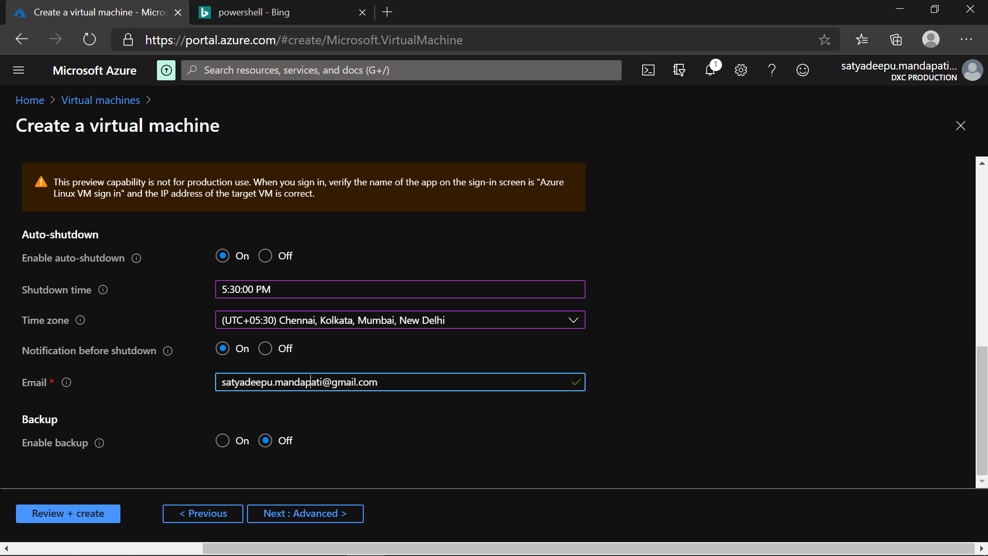

(d). Setting up a Microsoft malware Security Extension to the Machine

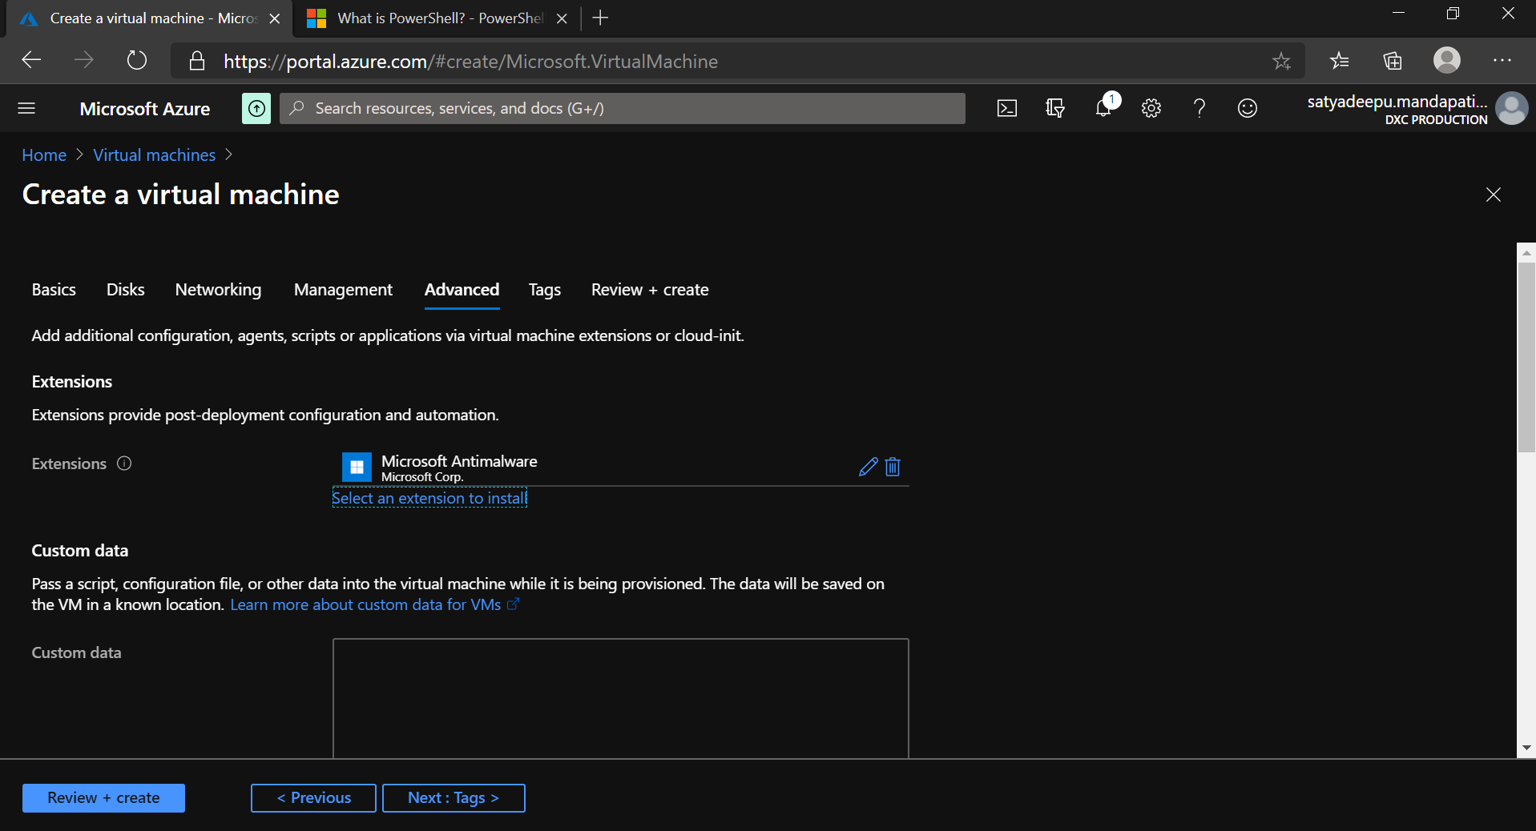

(e). The additional disk is spilt into 3 Drives in the VM

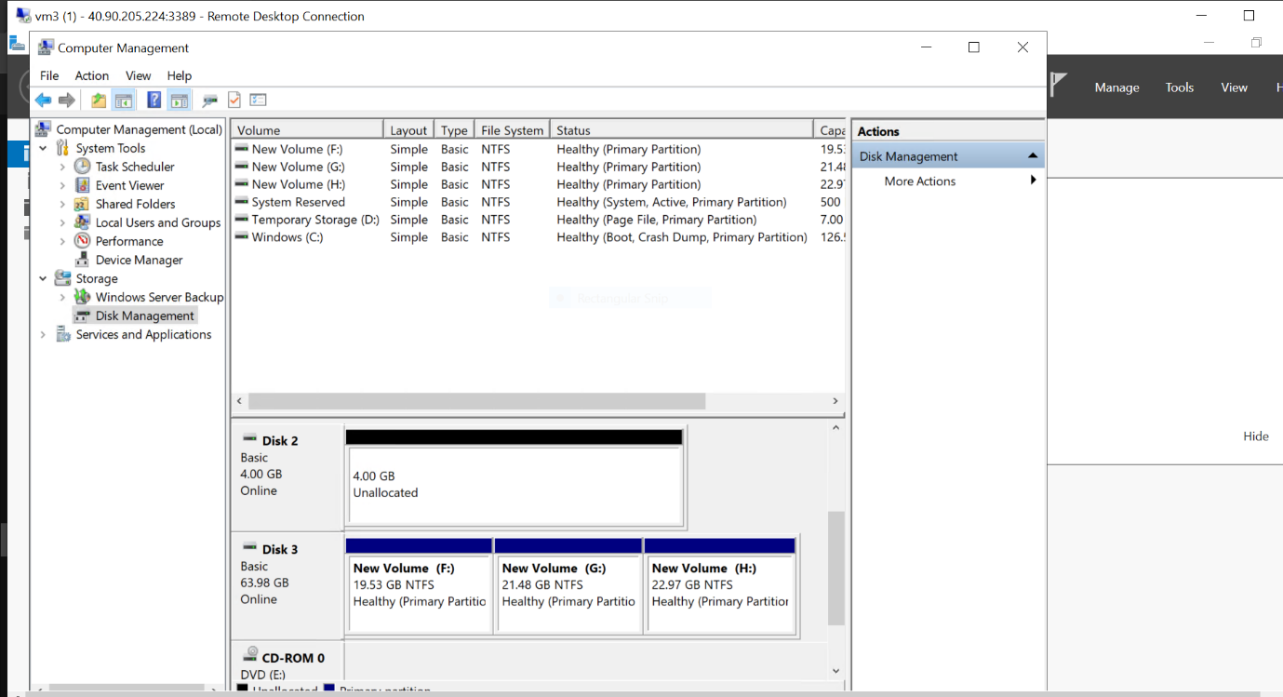

(f). Creating users to access The VM

